KALAWA ARMS SHOP

The main objective of the gun shop website is to provide an online platform where customers can view available firearms and related products while promoting responsible and legal ownership.
Goals:
To showcase products such as rifles, pistols, accessories in an organized catalogue.
To increase brand awareness and attract new customers.
To provide information about firearm safety, licensing and legal requirements.
To enable customer inquires through a contact form or communication channels.
To build trust by emphasizing compliance with local law and responsible sales practices.
Target Audience:
Adults aged 25-60 years
Individuals interested in firearms for Security, Sport shooting or professional use.
Licensed firearms owners or those selecting legal ownership.
Demographics:
- Gender: Primarily male (but inclusive of all genders)
- Location: Mainly within Botswana (or local region)
- Occupation: Security personnel, law enforcement, hunters, sport shooters, private citizens
Technical Aptitude:
- Basic to intermediate internet users
- Familiar with browsing websites, viewing products, and filling out forms
- Use of smartphones and computers to access the website
- Prefer simple, clear navigation and fast-loading pages

c. Type of Website / Content
Type:
- Product Catalog Website – Displays available firearms and accessories
- Informational Website – Provides legal, safety, and company information
Content:
- Product listings with images and descriptions
- About the business (mission, licensing, compliance)
- Contact page for customer inquiries
- Safety guidelines and legal requirements for firearm ownership

2. Information Design & Taxonomy
a. Information Design:
The website content is organized into clear categories to make navigation simple and user-friendly. The structure ensures users can easily find information about products, the business, and how to make inquiries.
Main Categories:
- Home
  - Introduction to the business
  - Featured products
- Products
  - Rifles
  - Pistols
  - Shotguns
  - Accessories
- About Us
  - Company background
  - Mission and values
  - Legal compliance
- Contact
  - Contact form
  - Phone and location details
Storyboard Flowchart

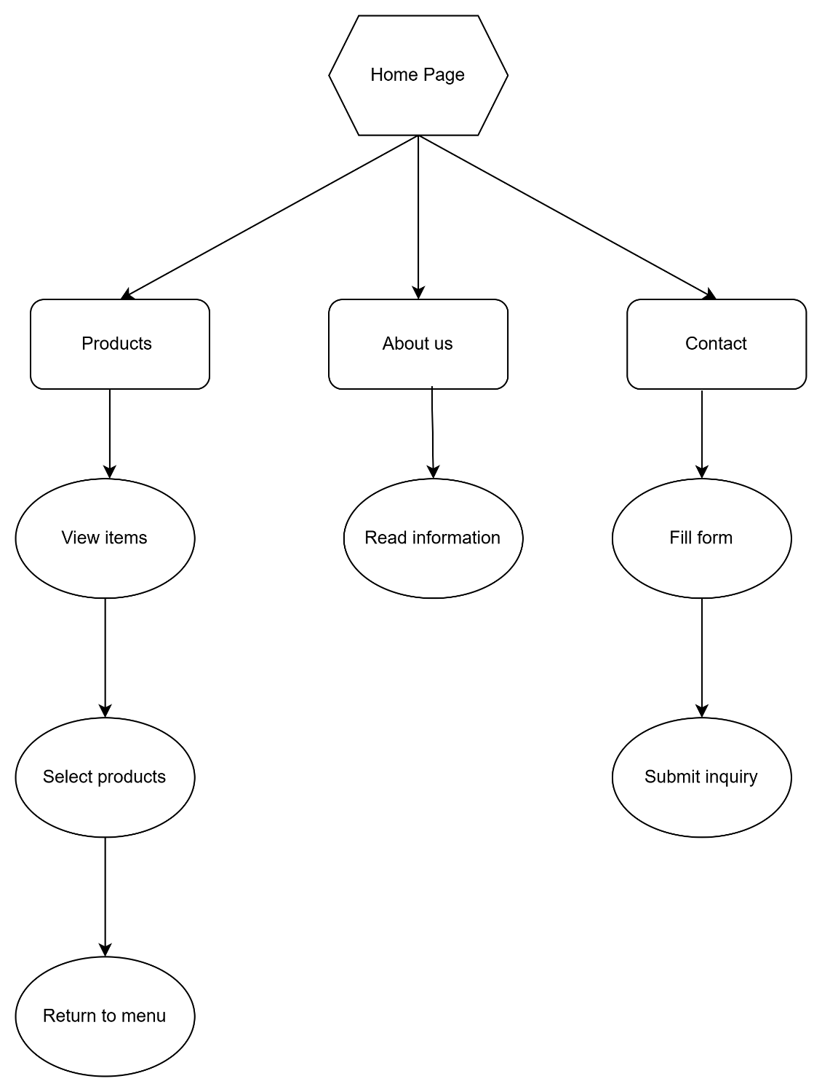

4. Technical Brief

Technologies
HTML5- for structuring pages
CSS3- for styling
JAVA Script-for adding interactivity

Software Tools
Draw io- for diagramming
Visual Studio – code editor

Resources
GitHub- for saving versions of code

